Govt. Degree College, Jammalamadugu
Kadapa, District
Affiliated to Yogi Vemana University
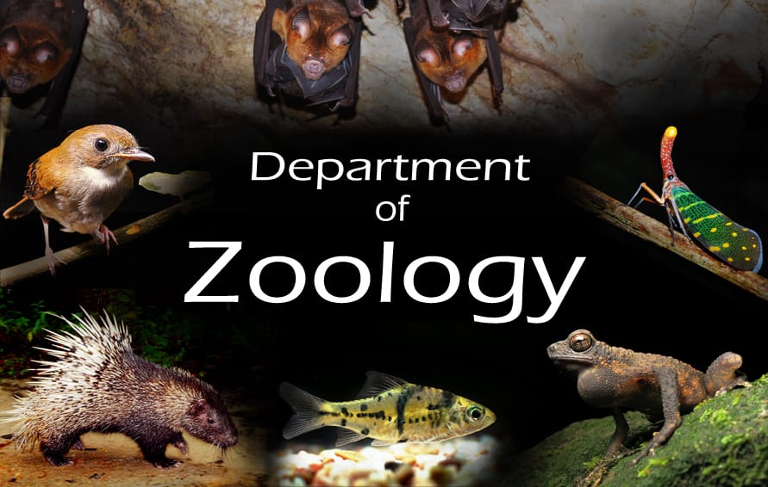
Faculty Profile
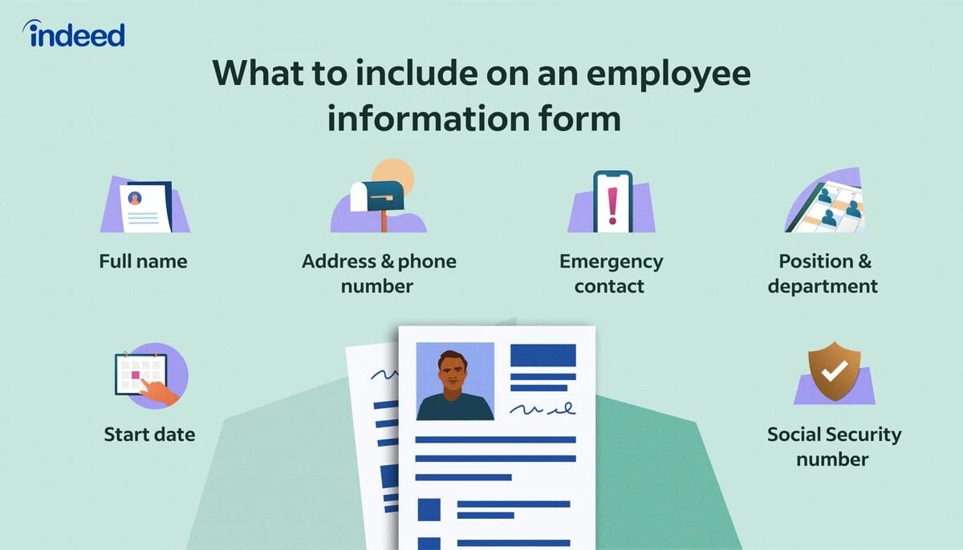
Govt Degree College
Jammalamadugu
PROFILE OF THE FACULTY
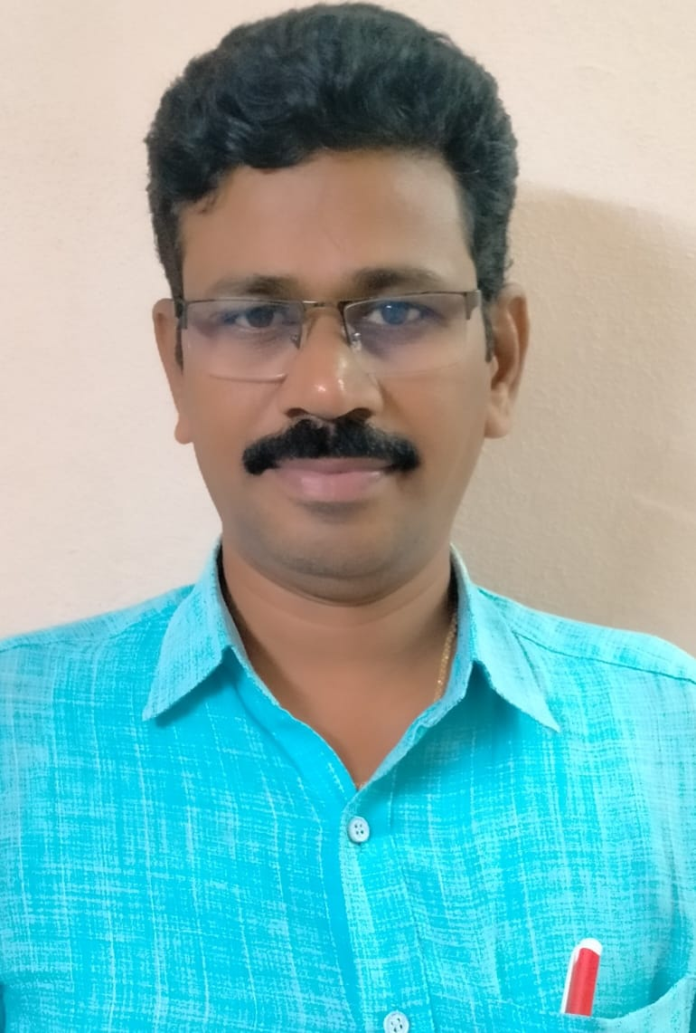

Name : Dr.V.Ravisekhar
Fathers Name : V.Ramanna
D.O.B : 15-04-1977
Date of Joining : 16-10-2009
CFMS ID : 1000088191
Mobile No : 9440853081
E-Mail ID : dr.v.ravisekhar2014@gmail.com
Designation : Contract Lecturer
Department : Zoology
Educational Qualifications : M.Sc,Ph.D.
Professional Experience in
Different Capacities : 15 Years
Date of Joining in this college: 08-07-2022, K Scale of Pay : 61,960/-

EDUCATIONAL QUALIFICATIONS

COURSE | BOARD/UNIVERSITY | SUBJECTS | YEAR OF PASSING | DIVISION | PERCENTAGE
S.S.C | B.S.E | GENERAL | 1992 | II | 54%
INTERMEDIATE | B.I.E.,HYD | BI.P.C | 1994 | II | 56%
B.Sc | S.V.UNIVERSITY | C.Z.S | 1997 | I | 62%
M.Sc | S.K.U | Zoology | 2002 | I | 70%
Ph.D | S.K.U | Zoology | 2007 | I | AWARDED

Achievements
Attending many seminars,webinars and deliver many speeches as guest faculty.
Work Experience
Worked as contract lecturer in SVB govt degree college,koilkuntla from 2009 to2014
Worked as contract lecturer in SGTRM govt degree college, yerraguntla from 2014 to 2019
Worked as contract lecturer in PSC&KVSC govt college, nandyal from 2019 to 2021
Worked as contract lecturer in SKR&SKR Govt college for woman(A),Kadapa from oct-2021 to 5-07-2022
Working as contract lecturer in zoology at GDC , Jammalamadugu from 8-07-2022 to til today
Contact Address
Dr.V.Ravisekhar
Dept of Zoology
Govt. Degree College
Jammalamadugu
Kadapa Dist-516434

